Module Name: Login Page - Functional & UI Test Cases
Test Case ID:L01
Environment:Android, Snapchat App,https://snapchat.com

Scenario: log in with valid credentials
Test Steps:
- Enter username:
- Enter Password:
- Click on login:
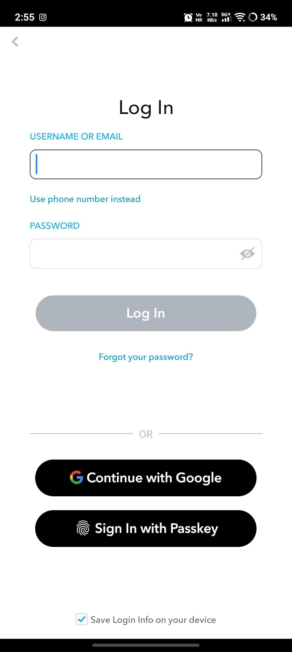

- Scenario ID: 1a
- Scenario: Login with valid credentials
Test step:
- Enter valid Username (darshita.2007)
- Enter valid Password (.......)
- Click Login

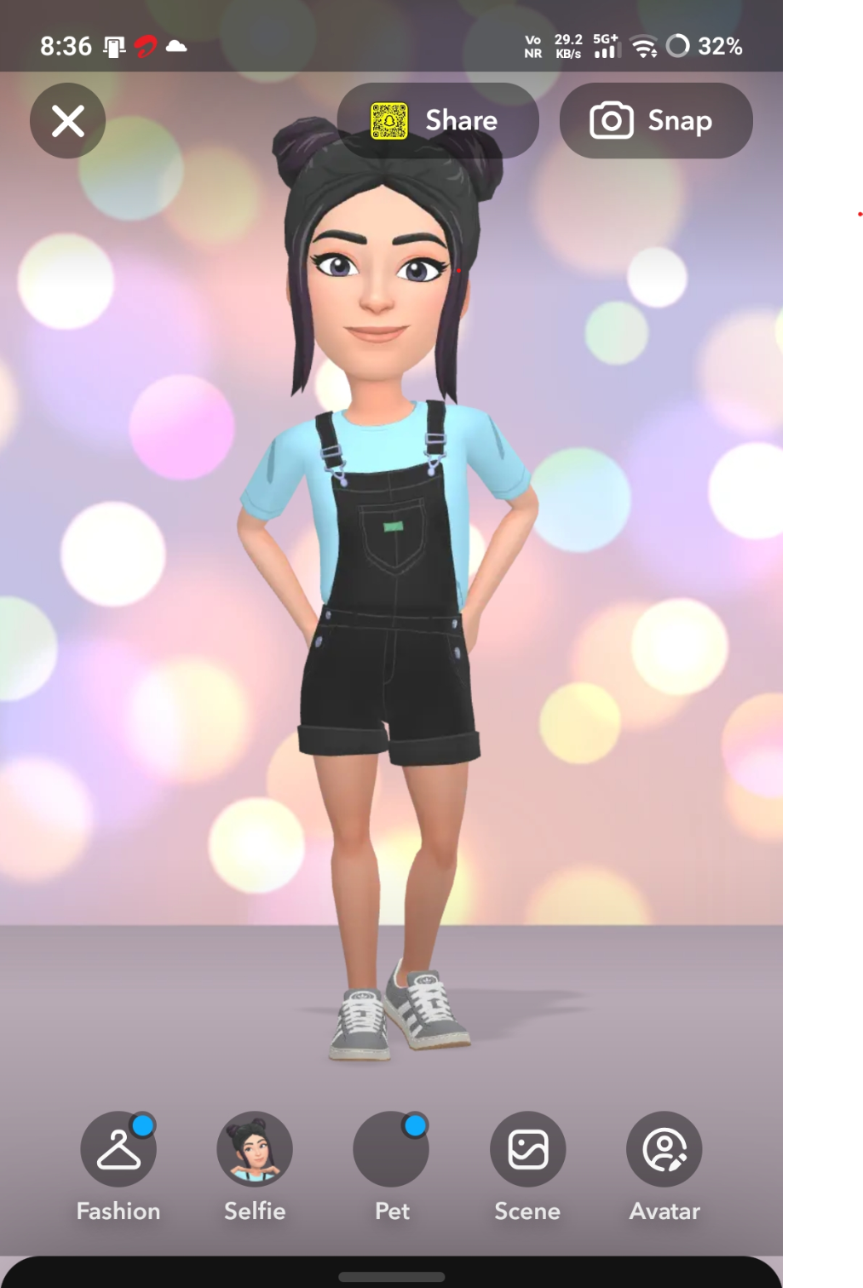

- Scenario ID: 1b
- Scenario:Login with invalid username
Test step:
- Enter invalid username(darshita..2006)
- Click on login
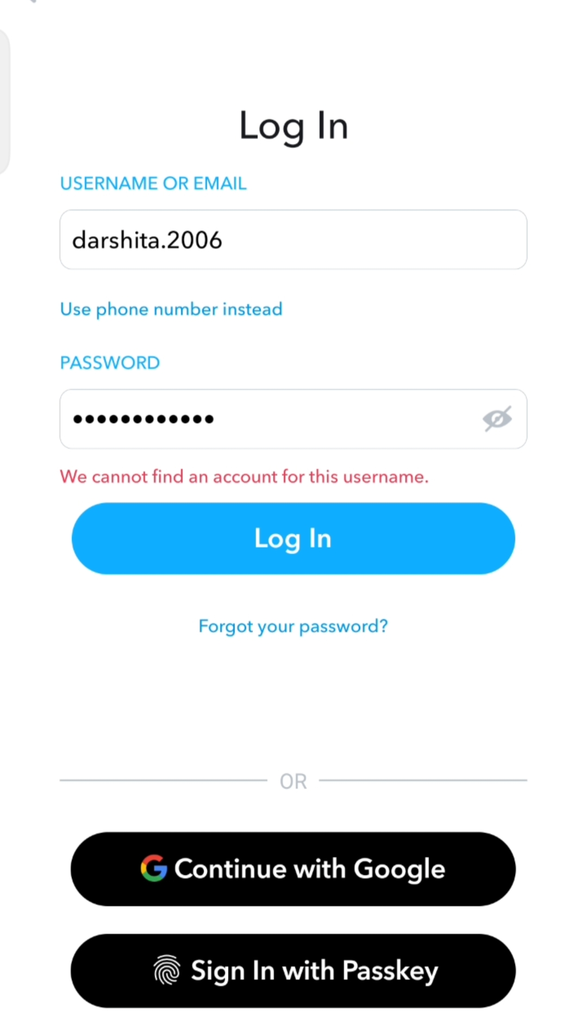

Scenario ID: 1c
Scenario:Login with invalid password

Test step:

1.Enter valid Username (darshita.2007)
2.Enter invalid Password (abcd123)
3.Click Login

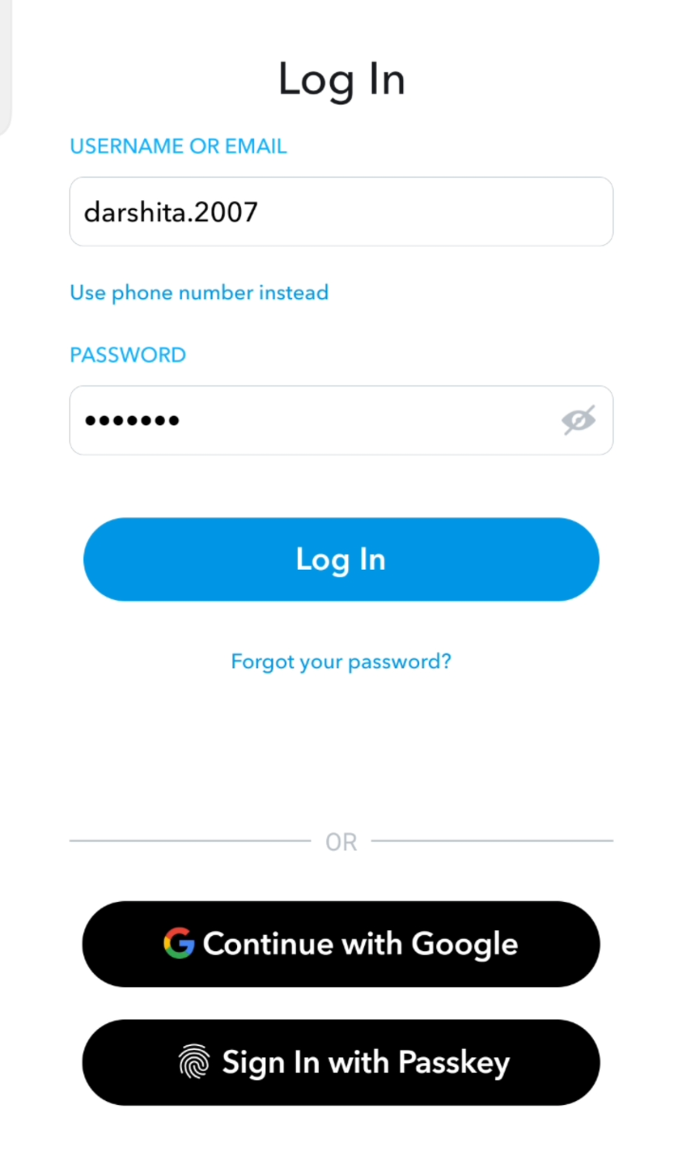

- Scenario ID: 1d
- Scenario:both blank
Test step:

1.Leave username & password blank
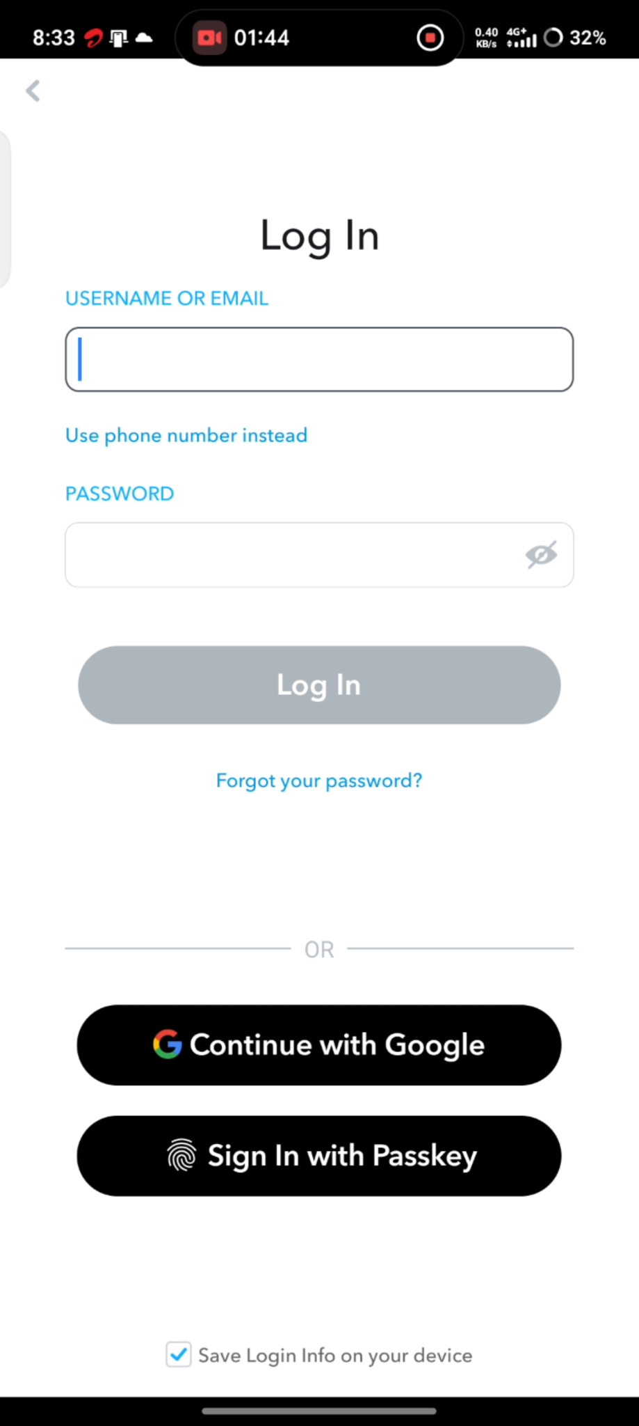
2.Click on login

- Scenario ID: 1e
- Scenario:Login with empty password
Test step:

1.Leave Password blank
2.Click on login
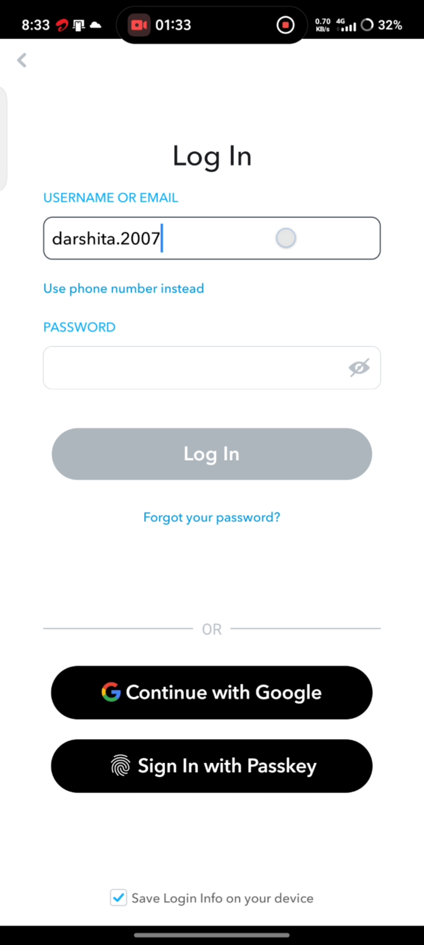
Screenshot:

- Scenario ID: 1f
- Scenario: Empty username
Test step:

1.Leave username blank
2.Click on login
Screenshot:
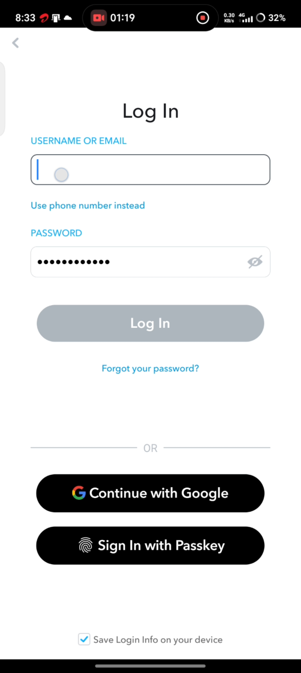

- Scenario ID: 1g
- Scenario: Logout
Test step:

1. logout
Screenshot:
